Beechcroft Infants School
Prospectus

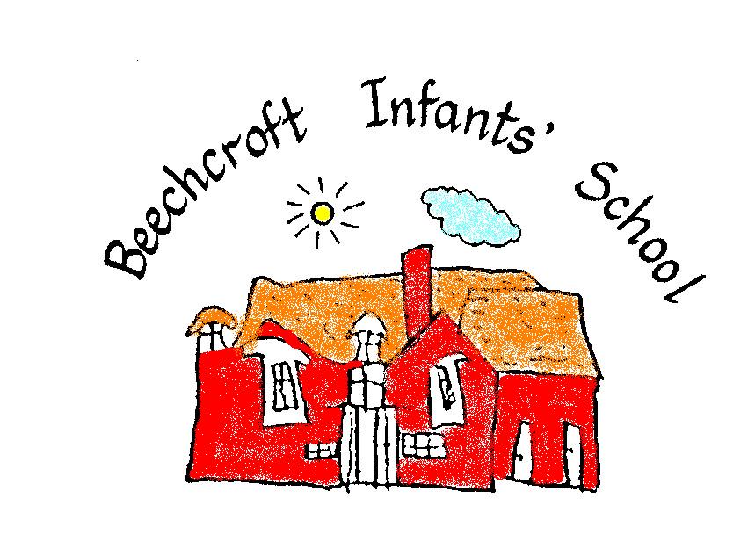

2026 - 2027

Dear Parents and Carers

We are excited to welcome your child to our school, and we hope that this will be the beginning of a long and happy association with the school.

This Prospectus is designed to give you more information about the school which we hope will be helpful.

Please do not hesitate to ask if something is unclear or you have questions that are still unanswered. We will always be pleased to answer your query.

~~~***~~~

IMPORTANT INFORMATION

We are currently reviewing our classes for September 2026 and are unable to advise you of our teaching structure at this time

Please be assured that we will let you know this information as soon as possible.

From October 2026 we will be joining The Blue Kite Academy Trust. More information will be shared to parents and carers as soon as this is available.

OUR SCHOOL ETHOS, VALUES AND CURRICULUM

Our Ethos and Vision
Beechcroft Infants School is a caring and inclusive community where every child feels safe, valued and proud to belong. We nurture happy, confident learners through kindness, respect and trust, placing emotional wellbeing and positive relationships at the heart of school life. With a love of learning, strong foundations in reading and rich first-hand experiences, we help every child grow academically, socially and emotionally.

Our Values
Our values of kindness, thankfulness, friendship, resilience, courage, forgiveness, honesty and respect are woven through daily school life and reflected in our simple school rules: Ready, Respectful and Safe.

Our Curriculum
Our curriculum is designed to spark curiosity, inspire creativity and support every child to thrive. Learning is engaging, purposeful and progressive, with strong foundations in spoken language, vocabulary, phonics and reading. We provide an inclusive curriculum that reflects our diverse community, promotes resilience and confidence, and gives children meaningful opportunities to explore, question and achieve.
Through enriching experiences, visits, visitors and practical learning opportunities, we broaden children’s understanding of the world and help them develop independence, cooperation and a love of learning. By working closely with families, we ensure that children leave Beechcroft as happy, confident learners who are well prepared for the next stage of their education.

OFSTED
The school has undergone several very successful Ofsted Inspections, the most recent being in March 2024. The Ofsted inspectors graded the school as GOOD.
Copies of reports are available on the Ofsted website if you would like to see these.

SCHOOL HOURS
School gates open at 8.45am in the morning and 2.55pm in the afternoon
Foundation Stage
Morning Session - 9.00am – 12.00pm
Afternoon Session – 1.00pm – 3.00pm

Year 1 and 2
Morning Session - 9.00am – 12.15pm
Afternoon Session - 1.15pm – 3.00pm

The school caters for children from the ages of 4-7 years.

ADMISSIONS ARRANGEMENTS POLICY
The Local Education Authority is responsible for admissions to Beechcroft Infants’ School.
Our Admissions Policy along with guidance from Swindon Borough Council can be found on our website.

WRAP AROUND CARE (Extended Schools)
We run a Breakfast Club every morning in term time.
The club runs between 7.45 – 8.45 a.m. and is supervised by members of staff.

Bear Cubs is an extended care facility. This is also run by members of school staff and operates 4 sessions daily. The sessions run from 3.00pm – 3.30pm, 3.00pm – 4.00pm, 3.00pm – 5.00pm and the later session runs from 3.00pm – 5.45pm. Children receive a light snack at 4.15pm.
Please contact the office for current pricing.

USEFUL INFORMATION
Beechcroft Infants School, Beechcroft Road, Upper Stratton, Swindon, SN2 7QE

Telephone Number: 01793 823278

School website address: www.beechcroft.swindon.sch.uk

Headteacher: Mrs J Rutt

Chairperson of the Governors: Mr R Williams

School Business Manager: Mrs S Perrett

Please direct any correspondence to:
Sally Perrett - admin@beechcroft.swindon.sch.uk

AFTER SCHOOL CLUBS
All children are given the chance to join after school clubs to enrich the curriculum. These may include football, ICT, art and crafts and choir.

COMMUNICATION
We try hard to communicate comprehensively with parents and carers. We send out termly newsletters with important dates on as we know how hard it is to plan ahead with busy lifestyles.
We also have a texting service which we use to notify you of activities and meetings etc.
Our website is very comprehensive and is updated on a regular basis. This can be found at www.beechcroft.swindon.sch.uk.
This will give you up to date information about the school, the curriculum, topics that are being studied within year groups and all our parent meetings to discuss the curriculum and your child’s progress within school.

SAFEGUARDING
Beechcroft Infants’ School is committed to Safeguarding to ensure the welfare and safety of all children in school.
We believe that children have a right to learn in a supportive, safe and caring environment which includes the right to protection from all types of abuse. We expect all staff and volunteers to share this commitment.
We follow the strict guidelines for Safer Recruitment and all the adults, including Governors, external staff and volunteers have been vetted to ensure your child will be safe in our school.
All staff are trained to ensure that our practice is in line with the Keeping Children Safe in Education Government guidance. This includes keeping in school records of key observations and individual records for repeating patterns or concerns. We always strive for appropriate communication with parents and carers.
SPECIAL EDUCATIONAL NEEDS AND DISABILITY
The school has a Special Educational Needs and Disability Policy which parents can access on the school website. The school’s SENDCo (Miss S Kew) has responsibility for coordinating special needs throughout the school and she liaises with parents, teachers and outside agencies to provide the best support for children.

Our Equality Policy is in place to ensure that children with disabilities are not treated less favourably to other children.

For our Local Offer and further SEND information please see our school website.

PICK UP AND DROP OFF
When you drop off or pick up your child from school, please do not bring your vehicle onto the school site. There is a free car park by St Philips Church and road parking on St Philips Road and Haig Close. It does get congested and we would appreciate your care and attention whilst parking. Where possible we would appreciate you walking your child to school.

PLEASE INFORM THE SCHOOL IF A DIFFERENT PERSON IS COLLECTING YOUR CHILD. They must be over the age of 16.

SCHOOL UNIFORM
Children may wear any combination of dark blue, white and grey.
Beechcroft School uniform can be purchased from: Monkhouse Schoolwear Specialist, Plaza 21, Sanford Street, Swindon, SN1 1HE. Telephone Number: 01793 520843
Non-branded uniform from supermarkets is also acceptable.
Water bottles and book bags can be purchased from the school. We strongly recommend purchasing a book bag for the safekeeping of reading books. Unfortunately, we do have to make a charge for damaged books.

PLEASE ENSURE ALL CLOTHING WORN IN SCHOOL IS LABELLED WITH YOUR CHILDS’ NAME.

ATTENDANCE AND HEALTH AND SAFETY
We ask that parents inform us promptly (by telephone) on the first morning of the absence if your child is unable to attend school.
It is very important that your child attends school every day unless there is a good reason for them to be absent (e.g. illness). Failure to let us know why your child is absent could result in an unauthorised absence being recorded for your child.
At Beechcroft we expect our pupils to achieve 95% attendance and above.
Holidays during term time will be unauthorised and a possible fine may be issued as laid out in the attendance guidelines published in August 2024.
If your child is unwell during the school day we will contact you to collect your child. Please ensure that your contact numbers are up to date and inform us immediately should these change,
Children must be clear of any sickness or diarrhea for 48 hours before returning to school.

SECURITY, HEALTH AND SAFETY
The school is monitored at all times by CCTV cameras and we have a very safe security fence with only one entrance during the day accessible to the public which is on a keypad entry system.
Principles of health, hygiene and safety are observed at all times. The school has a Health and Safety Policy, and annual Health and Safety checks and risk assessments are carried out. There are 10 Emergency First Aid trained adults in the school and 5 members of staff are Paediatric First Aid trained. We also have our own defibrillator.

SCHOOL TERM DATES 2026 – 2027

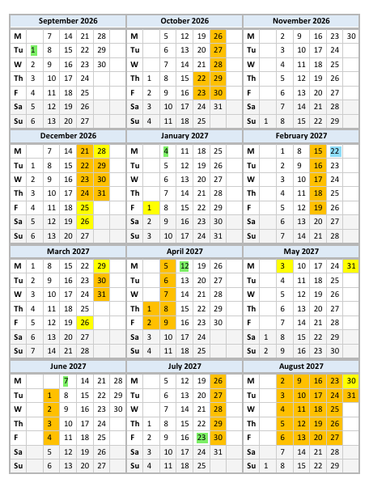

Teacher Training Days are highlighted in GREEN and the Blue Kite Academy day in BLUE

PHYSICAL EDUCATION
Children will be asked to wear PE kit into school on PE days.
Children need to wear dark shorts (blue or black) and a plain white T-shirt. For outside PE black or blue jogging bottoms can be worn along with a school sweatshirt. Children can wear trainers into school on these days.

MEDICINES
Only medicines prescribed by a doctor, including inhalers, can be given to the children during school hours. They must have full written instructions and parents must sign an indemnity form. Please note we will only administer antibiotics if they are required 4 times daily. Medication that needs to be administered at school MUST have a pharmacy label on the box/bottle.
If a child becomes ill whilst at school or has an accident requiring medical attention, it is very important that parents/carers can be contacted by telephone. We do ask for a number where we can reach you at all times.

FOOD AND DRINK AT SCHOOL
A free cooked school meal is provided daily, and we strongly encourage the children to participate in this. Although all meals are free they do have to be booked through www.parentpay.com and a login for this will be provided once your child is on roll. Please note these meals cannot be changed at short notice. Children can bring in a packed lunch. Please ensure this is healthy and does not contain nuts (including chocolate spread), sweets or chocolate bars. A small chocolate biscuit bar is permitted.
School milk is provided by Coolmilk for Schools (coolmilk.com). Soft drinks such as squash or water (not fizzy or energy drinks please) may be brought to school for throughout the day. We ask that drinks are brought from home are in a leak-proof container which is clearly labelled with the child’s name. Please refrain from carrying any drinks bottle in your child’s book bag as we are trying to protect our new reading books from water damage.
Children will be given a piece of fruit or veg for their mid-morning break. Snacks from home are not required.

JEWELLERY
We politely request that no smart watches or unnecessary jewellery are worn. Children are only allowed to wear stud earnings.

Finally, we wish you and your child every success and happiness at our school, and if you have any queries, worries or concerns, do not hesitate to come and talk to us about them. We are very friendly!!

