
The Zones of Regulation Information Sharing Session
Monday, 9th February at 6:00 pm
The Zones of Regulation (or “The Zones” for short) is the programme we use at Beechcroft. This programme is designed to help children develop skills in emotional understanding and self-regulation.
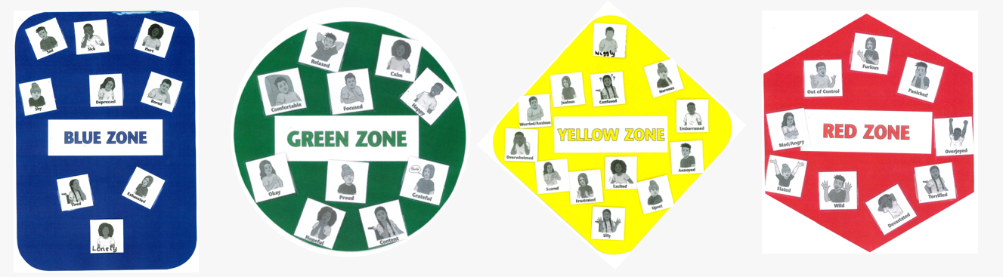
There are four coloured Zones (these will be explained in more detail during the meeting):
- Blue Zone – Low states of alertness: feeling sad, tired, sick, or bored. The body moves slowly.
- Green Zone – Calm and focused: happy, content, ready for learning and socialising. “Good to go.”
- Yellow Zone – Heightened alertness with some control: stress, frustration, anxiety, excitement, silliness, nervousness. Proceed with caution.
- Red Zone – Extreme alertness or intense emotions: anger, panic, terror, devastation, or elation. Loss of control.
Why are we using this in school?
When children and young people have coping skills to regulate their emotions, it helps boost resilience, self-esteem, and confidence. Learning to manage emotions can help them feel calm and engage positively with their education, which can, in turn, improve academic attainment. By focusing on understanding feelings and triggers, we aim to create a safe, supportive environment where children can build resilience and positive relationships. The strategies we share during the meeting will reflect these principles and show how they are embedded in our daily routines.
How do we use it in school?
The Zones of Regulation are used in every classroom, and the language surrounding them is part of our daily routine and strategy. The programme helps children recognise when they are in different Zones and begin to name the linked emotions. We talk about the importance of understanding how our own emotions (and behaviours caused by these) can impact others. The Zones form the foundation of our behaviour management and relationship-based practice at Beechcroft. This approach is closely aligned with our trauma-informed ethos. We believe that behaviour is a symptom of emotions, so it is vital to unpick issues and get to the root or ‘trigger’ of the problem to help the child move forward.
How can Zones help develop emotional understanding and support behaviour at home?
Using the same language in both home and school settings to support emotional awareness and behaviour is beneficial in many ways. Consistency in vocabulary provides reassurance for children and enables school and home to work in partnership. Having a planned response to heightened emotions and challenging behaviours can be helpful in tricky times and prevent escalation. Over time, this can result in a child being able to self-regulate through increased understanding of emotions and knowledge of tools that work for them.
Useful phrases include:
“I wonder if you are feeling (name emotion) because I can see that you are (describe behaviour). I can help you by (suggest a tool/strategy).”
“What do you need?”
Please scan the QR code below and complete the form by Friday 30th January to confirm your place.
Many thanks,
Mrs Hancock and Mrs Rutherford



