  Summertime Screen Time  Below is a website with some top tips for how to manage your child’s screentime during the summer break. https://www.betterscreentime.com/summer-screen-time-sanity-with-all-ages/     |  | Beechcroft Infants School  Online Safety Newsletter    July 2025
IMPORTANT ONLINE SAFETY MESSAGE:
Labubu Dolls
It has come to our attention that this latest doll trend has some online safety issues regarding the videos children are able to access on child friendly websites and YouTube.
These dolls are seemingly cute but have a monster looking face, which can seem creepy to young children.
Videos of the dolls can be accessed on child friendly websites, so therefore can bypass any parental settings that you may have.
Please be aware that these videos are making some children upset, scared and worried.
Please check all websites and videos that your child is accessing to make sure they are only accessing videos suitable for their age group.
Thank you for your cooperation in this matter.

  QR Code for Cebeebies Website:    https://www.bbc.co.uk/cbeebies  Scan the QR code to access the school website: |  |  | For this month’s newsletter, we have created a list of various websites that may be useful for you and your child over the summer holidays.  Cbeebies  The cebeebies website is an amazing resource.  There are a variety of games, quizzes, colouring pages to print and even shows to watch.  If you want to continue to support your child with reading or phonics over the Summer then why not take a look at the alphablocks resources:  https://www.bbc.co.uk/cbeebies/shows/alphablocks  Numberblocks also supports our Mastering Numbers Maths scheme.  https://www.bbc.co.uk/iplayer/episodes/b08bzfnh/numberblocks  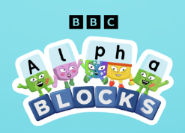  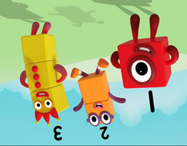  We all wish you a very happy summer holiday.  See you in September!
Users of this guide do so at their own discretion. No liability is entered into.
Current as of the date released. 17.7.25

